Searching Algorithms:
- Linear Search
- 2. Binary Search

🔍 1. Linear Search
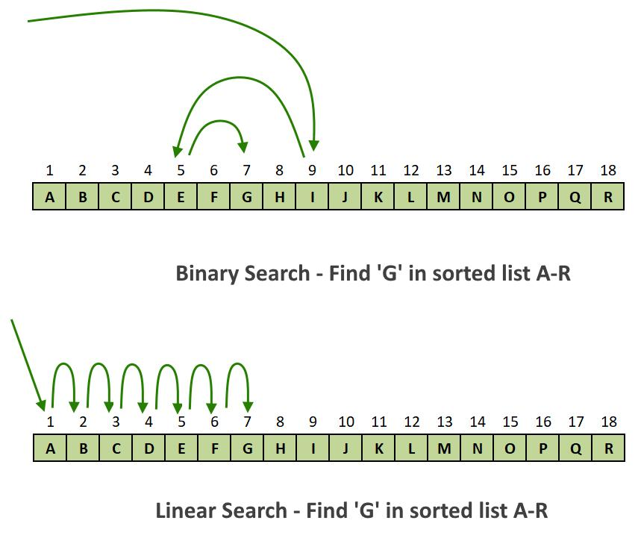

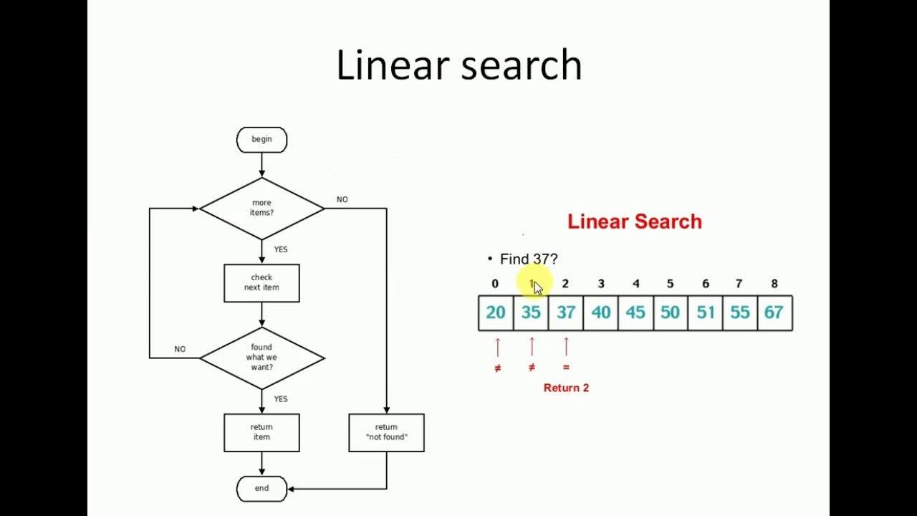
4
✅ Definition
Linear Search is a simple searching technique where each element in the list is checked one by one until the target element is found or the list ends.

📘 Explanation
- Start from the first element
- Compare each element with the target
- If match → return index
- If not → move to next element
- Continue till end

🎯 Use Case
- Small datasets
- Unsorted arrays
- When simplicity is more important than speed

⚙️ Algorithm
LinearSearch(arr, n, key):
for i = 0 to n-1:
if arr[i] == key:
return i
return -1

⏱ Time Complexity
- Best Case: O(1) (element found at first position)
- Average Case: O(n)
- Worst Case: O(n) (element at last or not present)

💾 Space Complexity
- O(1) (no extra memory used)

🔄 With vs Without Condition
✔ With Sorted Data
- Works fine
- But no advantage of sorting used
❌ Without Sorted Data
- Still works perfectly
- No requirement of sorting
👉 Conclusion: Linear Search works in both cases

🔍 2. Binary Search
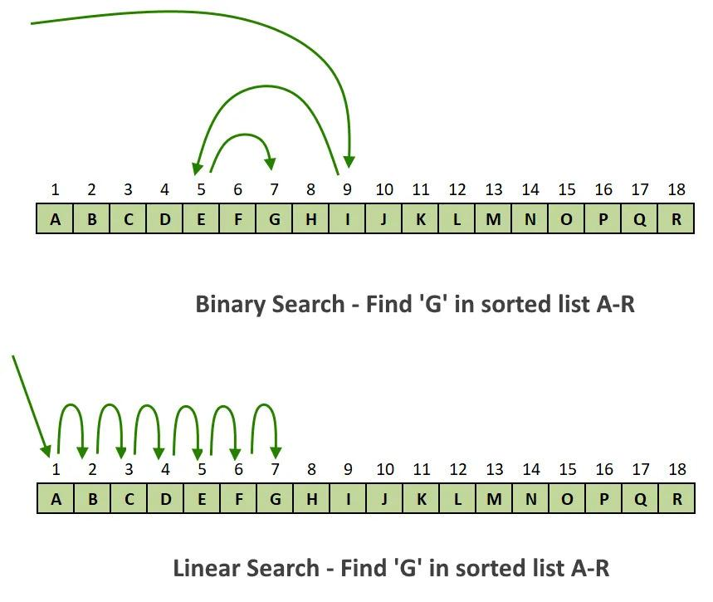
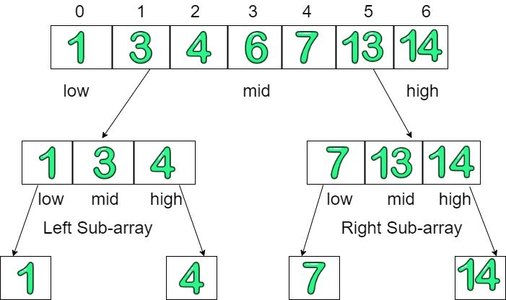
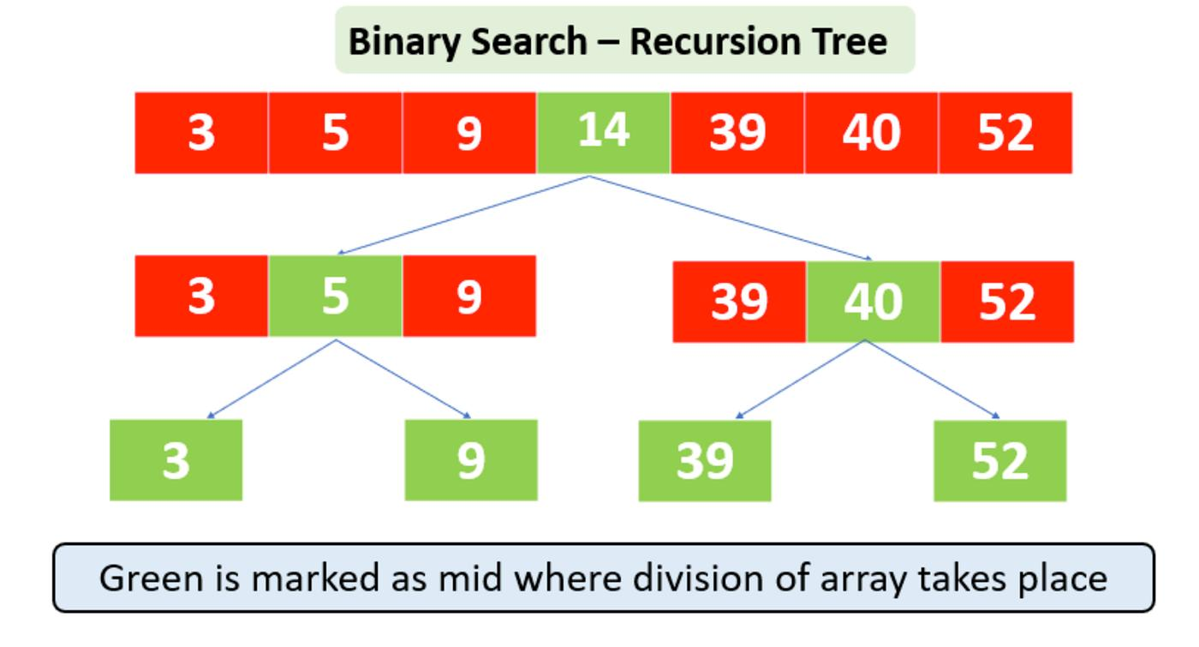
5
✅ Definition
Binary Search is an efficient searching algorithm that works by repeatedly dividing a sorted array into halves.

📘 Explanation
- Find middle element
- Compare with target
- If equal → found
- If smaller → search left half
- If larger → search right half
- Repeat until found or range ends

🎯 Use Case
- Large datasets
- Sorted arrays
- Fast searching required

⚙️ Algorithm
BinarySearch(arr, low, high, key):
while low <= high:
mid = (low + high) / 2
if arr[mid] == key:
return mid
else if key < arr[mid]:
high = mid - 1
else:
low = mid + 1
return -1

⏱ Time Complexity
- Best Case: O(1)
- Average Case: O(log n)
- Worst Case: O(log n)

💾 Space Complexity
- Iterative: O(1)
- Recursive: O(log n) (due to recursion stack)

🔄 With vs Without Condition
✔ With Sorted Data
- Works efficiently
- Very fast (logarithmic time)
❌ Without Sorted Data
- ❌ Does NOT work correctly
- Must sort first → adds extra cost
👉 Sorting cost: O(n log n)

⚖️ Final Comparison
Feature | Linear Search | Binary Search
Requirement | No sorting | Requires sorting
Time Complexity | O(n) | O(log n)
Speed | Slow | Fast
Data Size | Small | Large
Implementation | Easy | Slightly complex

🧠 Final Conclusion
- Use Linear Search when data is small or unsorted
- Use Binary Search when data is sorted and large

